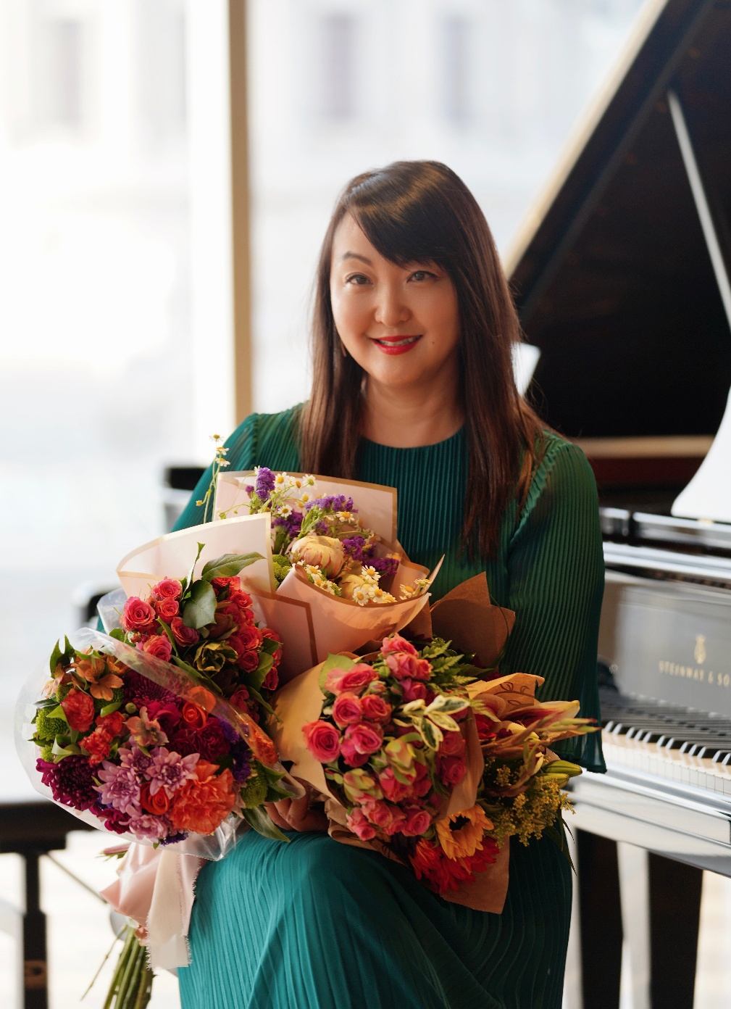
親愛的老師，
協會在今年的11月11日，10:30 a.m. -12:30 p.m.，在Joyful Melodies Music School很榮幸請到舊金山音樂學院室內樂教授，先修班鋼琴的李航教授來為我們講一場鋼琴教學與分享的講座，李航老師是先修班家長的搶手老師，她的學生得過國際級的大賽，像范克萊邦青少年、Hilton Head、洛杉磯李斯特國際大賽等等，學生有考上美國頂尖音樂院、常春藤名校，頂尖UC，繼續熱愛音樂。她將會分享她的教學經驗與和家長如何溝通的心得，協會做了一份問卷的表格，如果老師有任何問題，可以上去表格填寫。
https://docs.google.com/spreadsheets/d/18HoZes79fWH7GluvXYyEEq4Kdy8pKKZ2BvunSALFxN8/edit?usp=drivesdk
請老師預留時間參加。有興趣聆聽李老師的講座嗎？請點擊以下的連結報名。非會員的朋友或老師，想參加者需支付$20
Dear Teachers,
Our association is honored to invite Professor Han Li, Chamber Music Professor and Pre-College Piano Faculty at the San Francisco Conservatory of Music, to give us a lecture and sharing session on piano teaching. The event will take place on November 11, from 10:30 a.m. to 12:30 p.m., at Joyful Melodies Music School.
Professor Li is a highly sought-after teacher among Pre-College parents. Her students have won top prizes in prestigious international competitions such as Van Cliburn, Hilton Head, and the Los Angeles Liszt International Competition. Many of her students have gone on to study at top U.S. conservatories and Ivy League universities while continuing their passion for music.
In this lecture, Professor Li will share her teaching experience as well as her insights on effective communication with parents. Our association has also prepared a questionnaire form, where teachers may submit questions in advance:
Google Form Link
Please reserve the time to join us. If you are interested in attending Professor Li’s lecture, please click the link below to register. Non-members (friends or teachers) are welcome to join with a $20 fee.

